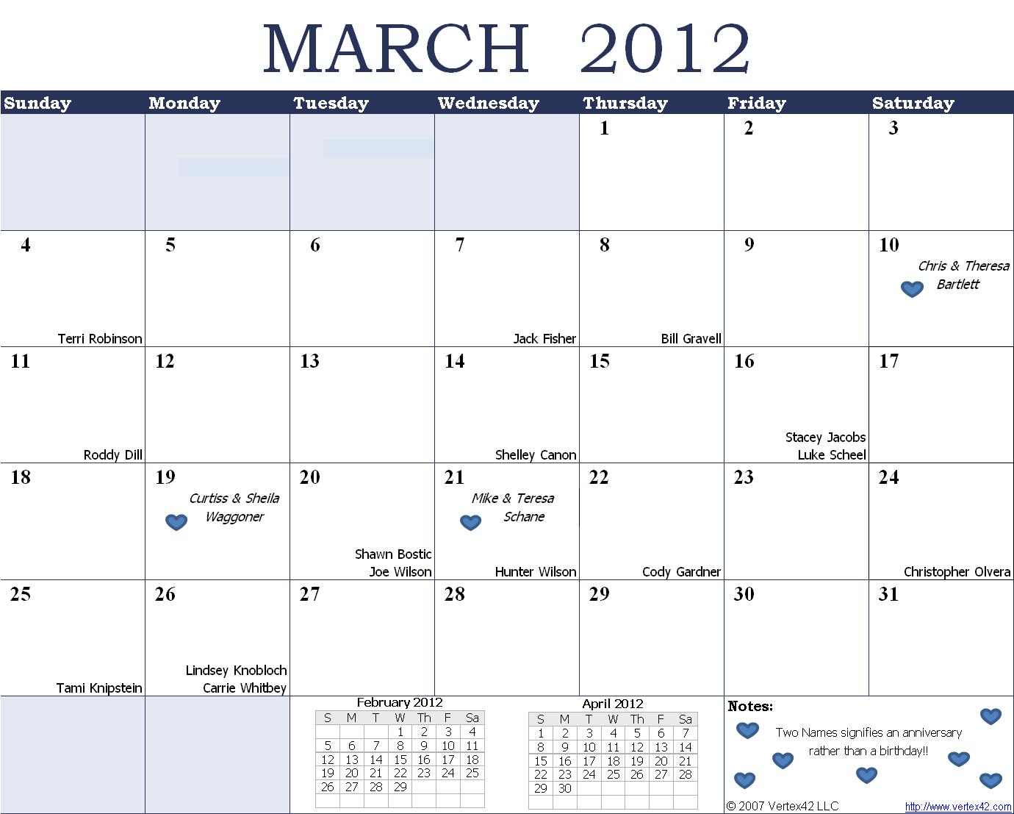

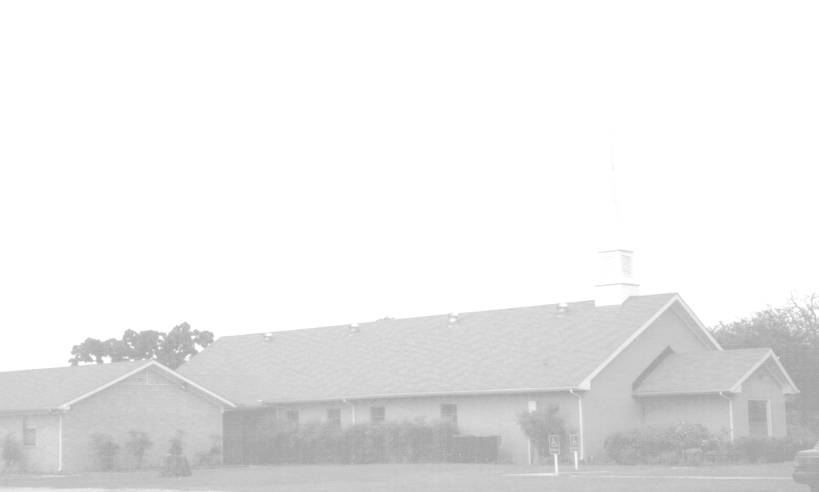
March Newsletter
151 YEARS of “Keep on Keeping On”
Knobbs Springs Baptist Church
1662 CR 305
McDade, TX 78650
Please email KnobbsSpringsBaptist@gmail.com to be removed from our mailing list. Thanks!


Non-Profit Organization
U. S. Postage Paid
Permit # 1
McDade, Texas

BAPTIST CHURCH

1662 CR 305

McDade, TX 78650

Phone: (512) 273-2743

Email: KnobbsSpringsBaptist@gmail.com

Pastor
Bro Mark McBride
(512) 229-6555
Txloves2fish@yahoo.com

Other Contacts
Cleyon Davis – Treasurer
(512) 856-2524

Kimberly Tabor – Office Manager
(512) 698-2804

March Ushers
Wesley McManus, Bill Gravell
Joe Daniel, Joe Wilson

March Hostesses
Dianne Stutes, Terri Edwards
Mickey Stanford, Judie Coffey

March Nursery
Schedule

4 0-2 Year Olds Becky Yount
3-4 Year Olds Cheryl Franklin
Helper Shayna Jacobs

11 0-2 Year Olds Cherilyn Wilson
3-4 Year Olds Debbie McBride
Helper

18 0-2 Year Olds Karen Cotton
3-4 Year Olds Jake & Stacey Jacobs
Helper

25 0-2 Year Olds Paula Knobloch
3-4 Year Olds Evelyn Robinson
Helper Mickey Stanford

Service Schedule:

SUNDAY
Sunday School 9:45 a.m.
Morning Worship Services 11:00 a.m.
Youth Activities 5:30 p.m.
Evening Services 7:00 p.m.

WEDNESDAY
Youth Worship 6:30 p.m.
Wednesday Services 7:00 p.m.

